**How to make a stealth game using Unreal Engine 5 and visual scripting**

What we need:

1. Unreal Engine 5.3.2

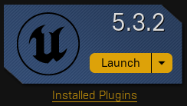

1. Create a new project using the “First Person Template”(Games->Third Person, Make sure blueprint is selected, uncheck “Starter Content”)

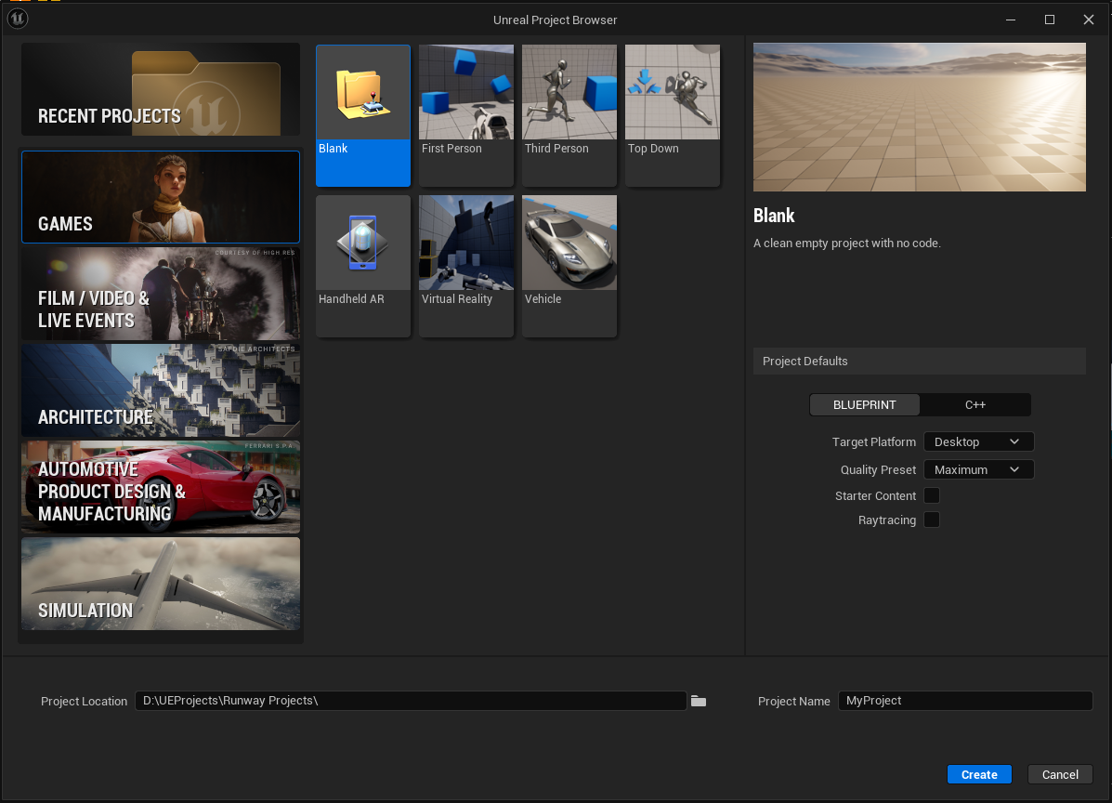

Step by Step:

Step 1: Creating the player

1. We will add some variables to the player. We will start with the movement speeds which are all floats. “CrouchSpeed” set the default to 400, “WalkingSpeed” default will be 600, and finally “SprintSpeed” default of 800.
   1. Next add a vector variable named “InitialCameraLocation” this will be for moving the camera smoothly while crouching.
   2. On begin play we will set the initial camera location equal to the relative location of the camera component. After that, on the character movement set the max walk speed to our walking speed variable, next set max walk speed crouched to our crouched speed.

* 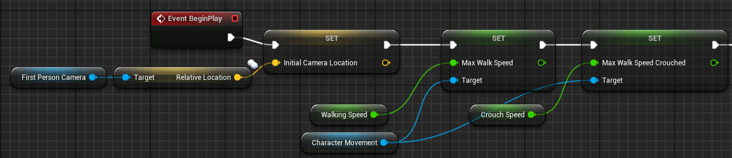

1. Now we will be adding the sprint and crouch functionality to the player. We will start this by adding extra input actions. Duplicate the “IA_Jump” blueprint, name the new input action to “IA_Sprint”, duplicate it again and rename it “IA_Crouch” since the crouch will be toggle instead of hold, open the blueprint and under the triggers array and delete the released element.

* 

1. Now we will add these to the new actions to the “IMC_Default” so we can set the keys to use. Add a new mapping with the “+” button, set it “IA_Crouch” and click on the keyboard button next to it and press the “left ctrl” button to set it to that. Create another new mapping and set it to “IA_Sprint” and do the same as before but this time click “left shift”.

* 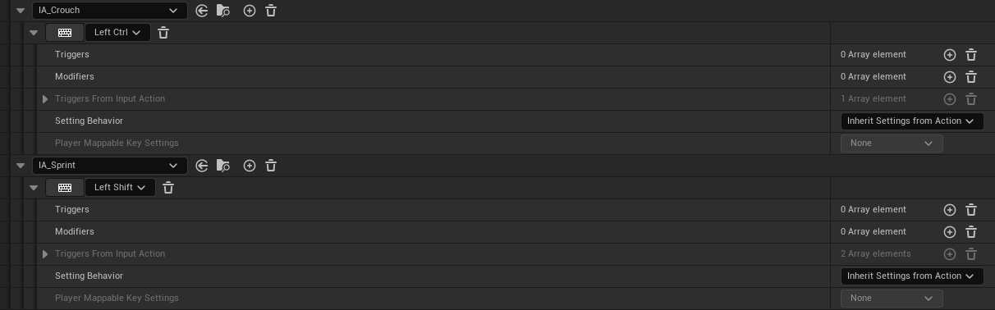

1. First select the character movement component and in the details panel search for “Can crouch” and make sure the box is checked.
   1. Next we will setup the crouch action event. Add this to the event graph, off the triggered exec pin attach it to a flip-flop node. Off of “A” call “Crouch” and off of “B” call uncrouch.

* 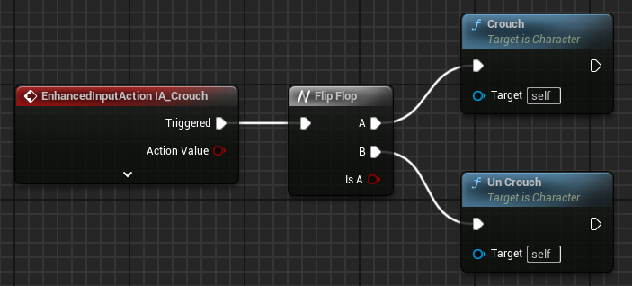
  1. Now to make the action more smooth we will add override the events “OnStartCrouch” and “OnEndCrouch”
     1. Create a timeline, this will be used instead of the tick event to generate a smooth movement of the camera from uncrouched to crouched and in reverse. Add a track to the timeline named “CrouchAlpha” add a key and set the time and value to 0, add another key with a time of 0.5 and a value of 1.
  2. Now connect the start crouch event to the play pin on the timeline, and on the end crouch event connect it to the reverse pin.
  3. Now we will lerp 2 vectors. First one will be our initial camera position, the other one we will break the position vector and make a new one where the X and Y components stay the same and we subtract 35 from the Z component. Connect the output of the make new vector into the B portion of the lerp, and our alpha will be the value returned from the timeline. Next we will set the relative location of the camera equal to the output of the lerp.
* 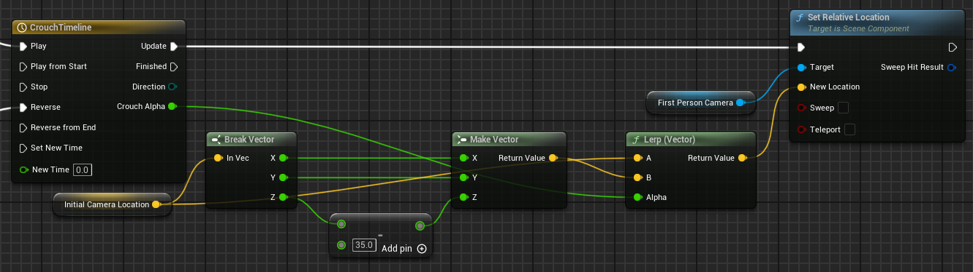

1. Now we will make the sprinting mechanics. First we will create some variables all of which will be floats.
   1. The first 2 will be “MaxStamina” and “CurrentStamina” set the default value for max stamina to be 100. Next variable will be “StaminaRegenDelay” and this delay will be in seconds, set the default to 5. Next 2 will be similar first one “StaminaUsageRate” and this will be the amount of stamina being drained each second, the other one will be “StaminaRegenRate” this will be the amount of stamina regenerated each second, the default values for these will 2 and 1 respectively.
   2. Now we will set up multiple custom events “OnStartSprint”, “OnEndSprint”, “BeginRegen”, “ConsumeStamina”, and “RegenerateStamina” and none of these will have input.
   3. We will start with the simpler events, for “ConsumeStamina” our first node will be a branch where we check that the value of Current stamina is greater than 0 AND make sure that the player is not currently moving. On the false branch we will call “OnEndSprint” and on the true branch we will subtract from our current stamina the value of “StaminaUsageRate” multiplied by 0.0167 to mimic a hard set delta time of 1/60th of a second.

* 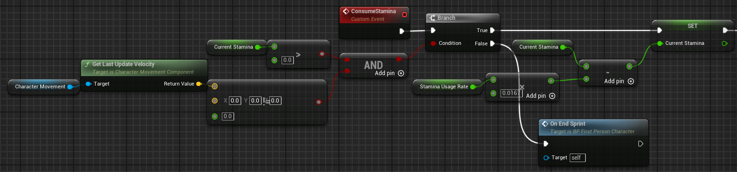
  1. We will make another variable and this will be of type timer handle and we will name it “StaminaRegen”. This will be used in this event, first we will check to see if the current stamina is less than the max stamina, on the false node we will set our current stamina to our max stamina, then using the timer handle call “ClearAndInvalidateTimerByHandle” on it so it will no longer be running. On the true branch set our current value equal to our current value plus the value of our stamina regen rate multiplied by 0.0167.
* 
  1. Now we will start the OnStartSprint event. We will take the character movement component and set the max walk speed to the value of our sprint speed, next we will clear and invalidate our stamina regen timer and we will check if the player is crouching or not, if the player is crouching we will call uncrouch and both paths we will create a new timer handle called “StaminaConsumption” and we will check if the handle is valid or not. If it is not valid we will create a timer by event, make sure the box for looping is checked and the time set to 0.0167, for the event connect it to “ConsumeStamina” and set the new variable to the returned timer handle.
* 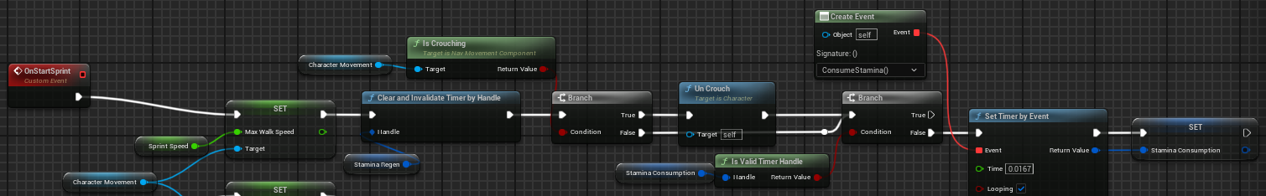
  1. Now onto the OnEndSprint. We will first start by setting the max walk speed to our walking speed variable, now clear and invalidate the stamina consumption handle, and now set a timer by event set the time equal to the stamina regen delay variable and the event handle will be our BeginRegen event.
  2. Now for BeginRegen we will start by clearing and invalidating the stamina regen handle, then set a new timer by the RegenerateStamina event and set stamina regen to the output handle.
* 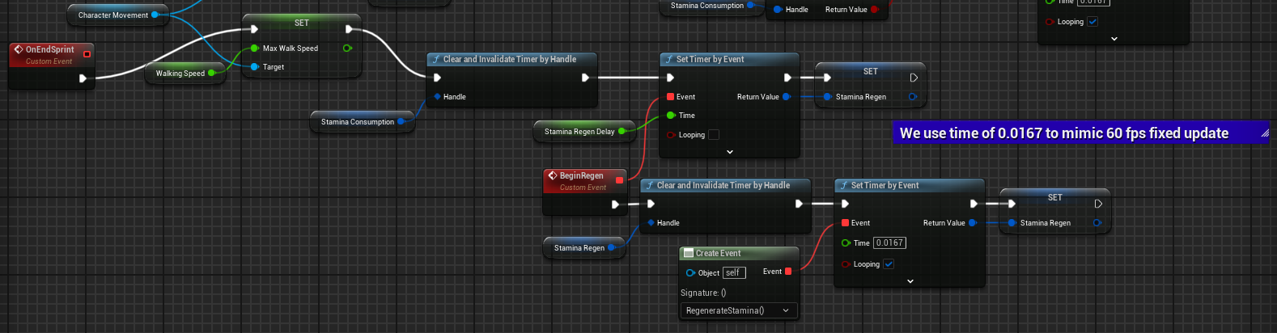
  1. Now finally the input handling for the sprinting. Add the IA_Sprint event to the event graph, call OnStartSprint from the start and ongoing nodes, then off of the cancelled and completed nodes call OnEndSprint.
* 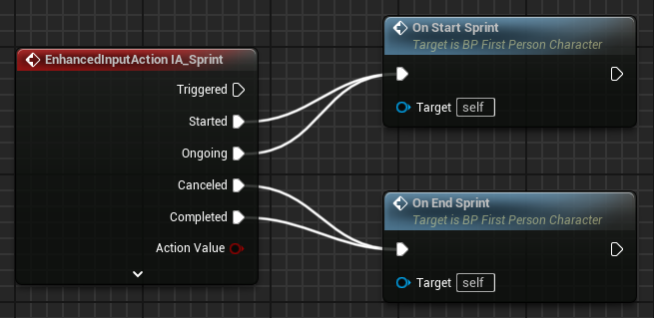



Step 2: Enemy AI type 1

1. We want our AI’s first behavior to be a patrolling behavior.
   1. We will start by making a new actor blueprint and name it “BP_PatrolPathPoint”.
   2. Add a cylinder to the components of the actor. Turn collision off and make sure the “Hidden in Game” checkbox is checked, set the X and Y scale to 1.25 and the Z scale to 0.1. Now we will Add an arrow component to indicate where we want the patroller to face when they stop at the checkpoint. Now we will create a custom debug material so we can easily see where we have placed the checkpoint in the world.
      1. Right-click the content browser and choose “Material” and name this “M_PatrolPointDebug”. On the main node in the graph, open the details panel and change the blend mode to “Translucent” and change the shading model to “Unlit”.

* 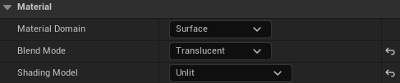
  + 1. Add a constant value node and a constant vec3 node, drag the vec3 pin into the “Emissive Color” and set the constant values to R: 0 G: 1 B: 0.1. Now put the singular constant value into the “Opacity” pin and set the value to 0.3. Now apply this to the cylinder component as its material.
* 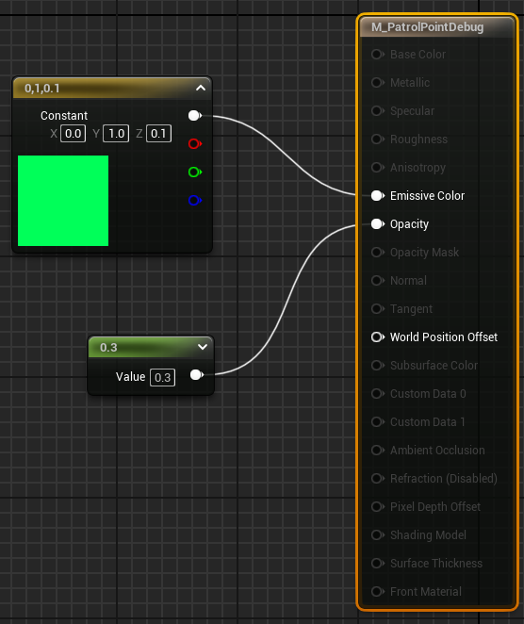
  1. We will have 2 custom events called “OnPatrollerEntered” and “OnPatrollerExit”. The on enter event will have an input of type character.
* 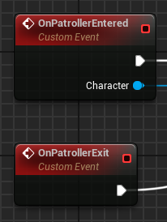
  1. Right-click the character pin and select “Promote to Variable”, name this “PatrollingCharacter”. We will use this reference later.
  2. Now we’re going to use the Tick event to lerp between the characters current rotation to the target location. Off of the tick we will use a gate with certain open and close conditions so the tick is not always running. Drag the exec pin of tick into the enter pin of the gate. The on enter event will open the gate and the on exit will close the gate. Get the actor rotation of the patrolling character and get the world rotation of the arrow, feed these values into the RInterp to node, and on the exit of the gate set the actor rotation of the character using the new location from the interp node.
* 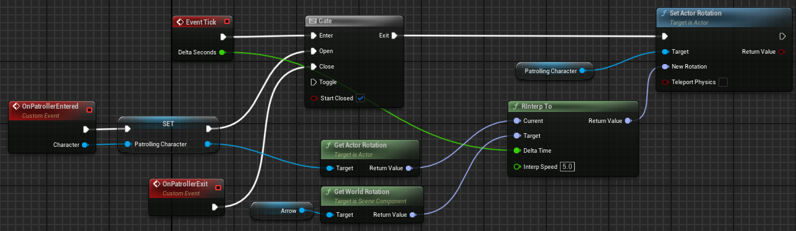
  1. Now make a new actor component blueprint and name it “BP_AIBehavior” this will host various variables for our behaviors. One variable named “PatrolPath” will be a map where the keys are our patrol points and the values will be float which will represent how long the patrolling character will stay at that point before moving along to the next one.
     1. Now create an enum blueprint and name it “EPatrolPathOutcomes” the first value will be “Loop” which will have it to where the patroller will keep looping through all of the points in the map, the next one will be “Return” which will have the patroller go from start to finish, then back to the path in reverse. And then “None” where the character will go through the path then remain idle on the last point.
  2. Now add another variable of this enum type to the actor component and name it “PatrolPathOutcome”.
  3. We will make our first Blueprint task to be used in a behavior tree. Create a new blueprint and in the all classes section search for “BTTask_BlueprintBase” and use this as our parent class, name our new task “BTTask_Patrol”. This will host all of our logic for the patrolling action.
     1. We are first going to add some variables to the patrol task. We will create the same map type as on our actor component and name it “Patrol Path”, well will add 2 integers, one named “CurrentPatrolIndex” and “PathDirection” and this will have a default value of 1. Next we will add a Pawn variable named “Owner”. We will have a patrol path outcome variable so we know how we want the patroller to behave. And finally we will have a reference to the current patrol point.
     2. Now override the “ReceiveExecuteAI” function, set owner to the controlled pawn input. On this pawn we will call “GetComponentByClass” and search for our “BP_AIBehavior” component. We will then check if the output is valid, if it is we will continue our logic, if it is not we will call “FinishExecute” with the Success bool unchecked.
* 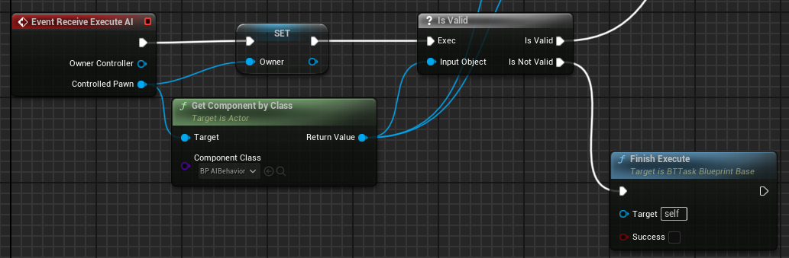
  + 1. Next we will set our copy of the patrol path outcome, then get the PatrolPath map and see if the length is greater than 0, if it is not we have an invalid map and we have to finish execute as failed. If it is greater than 0 then we will set our copy of the patrol path equal to the one we get off of the component. We will then make a new custom event named “MoveToPatrolPoint” and call it at the end of this execute.
* 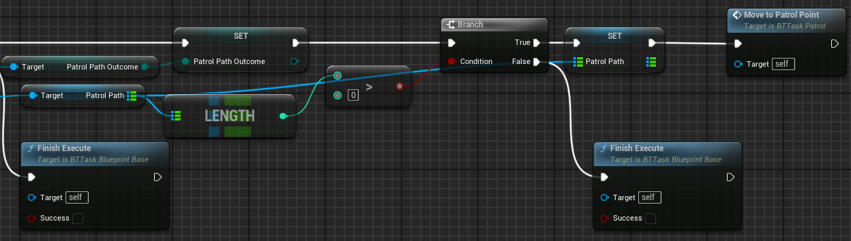
  + 1. Now we will implement the logic for the move to patrol point event. First thing we will do is get the keys from the map, then from the returned array we will put in our current index and get the actor at the index, then set our current point to this one, and then get the actor location and this will be where we will send the character. We will use the AI Move To node, for the pawn we will send in the owner and use the actor location for the destination node.
* 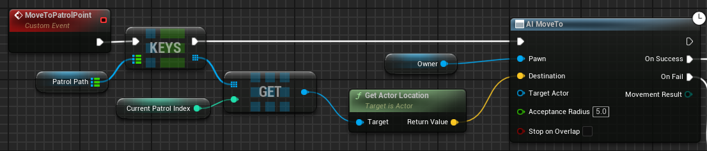
  + 1. If this node fails we will call FinishExecute with a fail, on success we will use our current patrol point to find the corresponding wait time value for the point and using a MAX node with our time input and the other input set to 0.05 this will allow us to have a seemingly 0 second wait time without breaking the AI. We will create a custom event named “OnEndWaiting” and we will set a timer by event and use this new event. After setting the timer we will call “OnPatrollerEntered” on our current patrol point and cast the owner to a character and send that into our character reference.
* 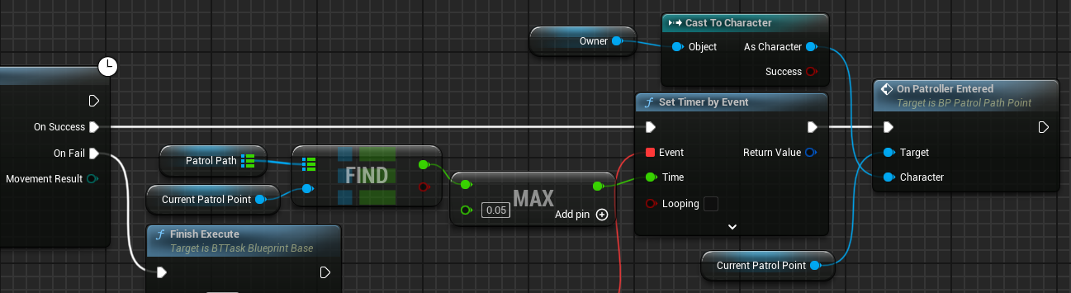
  + 1. The first thing we will do with our end waiting event we will call “OnPatrollerExit” on our current patrol point. Next we will set our patrol index equal to the sum of our current index and our path direction variable.
       1. Quickly we will create a pure function named “ValidMapIndex” with an integer input and a bool output.
       2. We will get the keys array of our map and use the node “IsValidIndex” and return the returned bool.
* 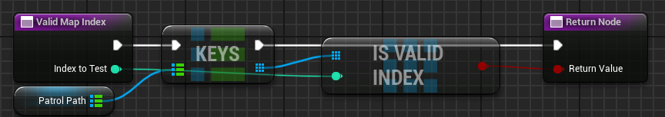
  + 1. After setting the value of our CurrentIndex we need to check to see if its valid, if it is valid we will call our MoveToPatrolPoint event to keep moving along the task. If it is not valid we will switch on our PatrolPathOutcome enum.
* 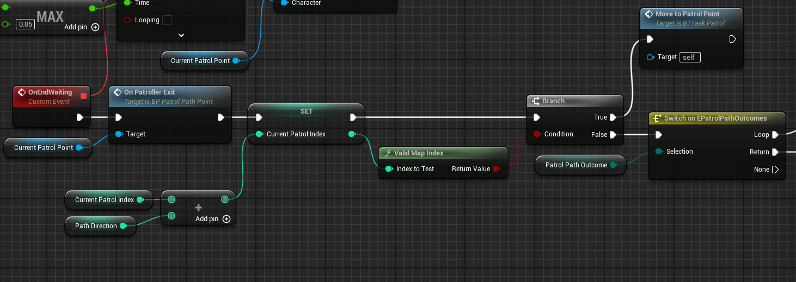
  + 1. Off the Loop pin we will set our current index to 0 and call MoveToPatrol point. On the return pin we will set path direction equal to its current value multiplied by -1 and then we will set our current index equal to the sum of itself and the path direction, then call our move to patrol point. The none pin will have no execution path off of it.
  1. Now we will create our behavior tree and a corresponding blackboard, name the behavior tree “BT_AIType1” and the blackboard “BB_AIType1”. On the blackboard we will add 3 new values, one of type “Object” and set the base class to “Actor” this will be named “TargetActor”, the other 2 keys to be added are both of type vector and will be named “TargetLocation” and “LastKnownLocation”.
  2. We will be filling out this behavior tree more, but for now we will add a selector node off of the ROOT, we will then have another selector off of that and we will name these so we have a better idea of what each one does “InvestigateOrPatrolSelector” will be this name, for now we will only put our patrol node on there. We will add a decorator to this selector that will determine if we go down this branch or not, it will be a blackboard condition, set it to abort self, key query is not set, and choose the key to TargetActor.
* 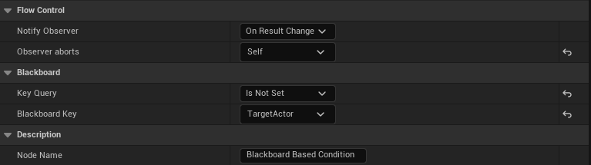
  1. Make another selector off of the previous selector, and now place our BTTask_Patrol under this new selector, and in case the patrol fails or isn’t set we will create a basic random movement task on the right side of the patrol node.
     1. Create a new task as we did before and make this one “BTTask_MoveRandom” we will have 2 float variables, both which will be instance editable. Name one “Radius”, and the other “AcceptableRadius”.
     2. We will start by overriding the ReceiveExecuteAI function. Get the actor location, then find a suitable point in a radius. The return of the random location node we will check if its true or false, if its false we will do nothing, if it is true we will have our AI character move to the location returned, on the success of the movement we will finish the execute successfully on fail we will also finish the execution but fail it.
* 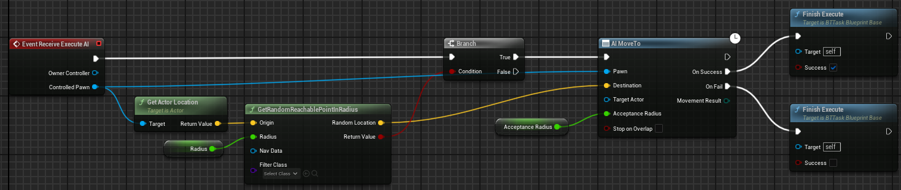
* 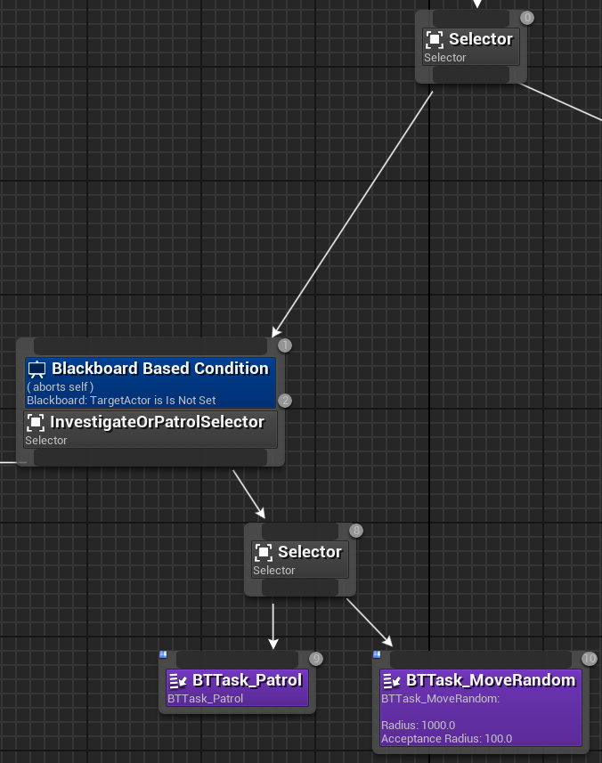

1. Now that the patrolling is done let’s set up the perception on the AI.We will first set up the vision perception.
   1. Now we will create a new blueprint with the AIController as the parent, name this “AIC_PatrolEnemyController”.
   2. First off we will add a PawnSensing component to the controller. For now leave the sense values at their default, except for the “SensingInterval” set this to 0.2. We will be revisiting the rest once we create the character.
   3. On begin play we will immediately start running the behavior tree by calling “RunBehaviorTree” and the asset will be “BT_AIType1”.
   4. We will override the “OnSeePawn” event on the PawnSensing component.
      1. First thing we will do is check to see if the pawn passed in is equal to our player character, if it is not equal to the player we don’t want it to do anything.

* 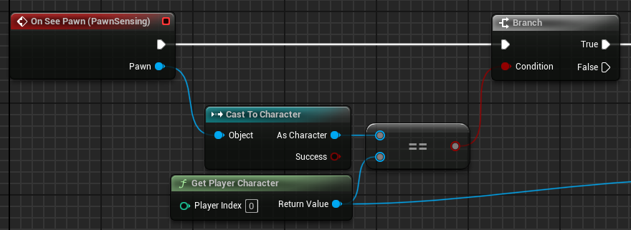
  + 1. Next we will get the blackboard and call set value as object, we will pass the player reference into this node and use the “Make Literal Name” node and the key name is “TargetActor”. Then we will use a retriggerable delay to decide whether or not the AI can still see the player, this node will reset the timer each time it is called, it is important that the time chosen is greater than our sensing interval, use 0.5. Then off of the retriggerable delay clear the key value at “TargetActor” and then set “LastKnownLocation” key equal to the player character’s location.
* 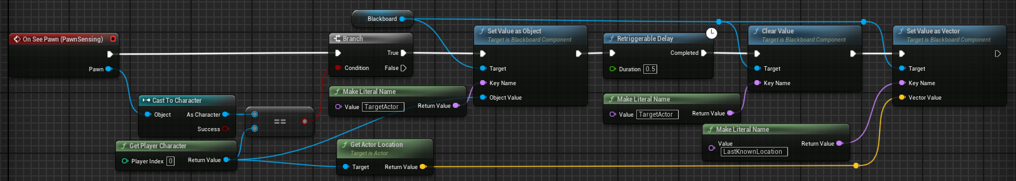
  1. We will override another event, this one is named “OnHearNoise” from the pawn sensing component.
     1. We will first check to see if the instigating pawn is equal to the player pawn, if it is then we will set our “TargetLocation” key on our blackboard equal to the location of the noise the AI heard.
* 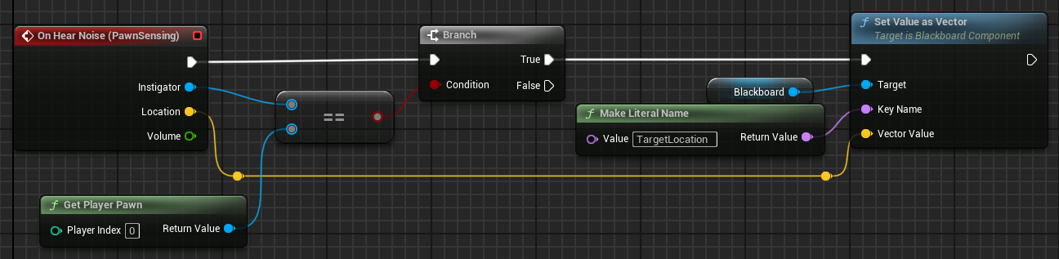
  1. Now we will add behavior tree paths to account for these new senses, and will start by creating a new task that will clear whichever blackboard value we tell it to.
     1. Name it “BTTask_ClearBlackboardValue”, add a variable of type “BlackboardKeySelector” and name it “BlackboardKey”. Now override the ReceiveExecuteAI function, using the variable we made call “ClearBlackboardValue” and then finish the execution as a success.
* 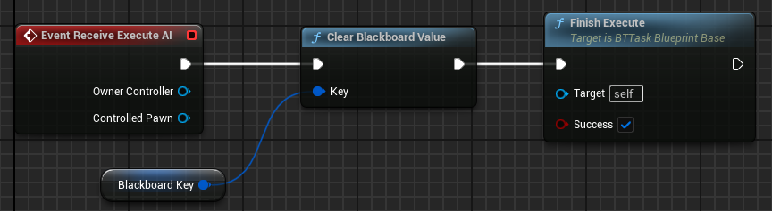
  1. Now back to the behavior tree. Off of the Investigate or Patrol selector, to the left side of our patrol task make a new sequence named “InvestigateSequence”. On this sequence we will add a decorator, on this we will have it abort itself, and set the key to “TargetLocation”.
* 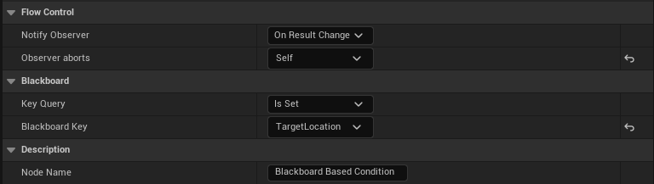
  1. The reason we use a sequence here is because it will go to the first task and if it is successful will move onto the next task, whereas the selector will go to the first task and only go to the next one if the first one fails, and we want all of these tasks to happen when investigating.
  2. Off of the investigation sequence the left most task will be a move to node with the blackboard key of “TargetLocation”, then once the AI makes it to the location it will wait for 2.5 seconds with a standard deviation of 0.5 seconds. Then once the wait is over we will clear the blackboard value with the task we made and have it clear the “TargetLocation” value.
* 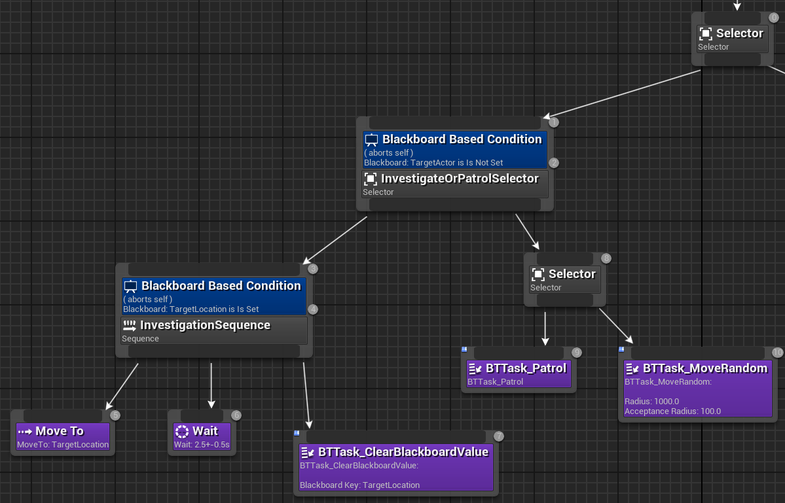
  1. We will also add a chase portion of the behavior tree. On the right side of the Investigate Or Patrol Selector off of the main selector we will add another selector named “ChaseSelector”, we will then on the left side we will add a sequence named “ChaseSequence” with a decorator with the settings aborts both, and the key value will be target actor.
* 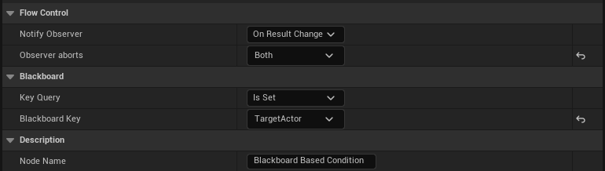
  1. Off of this sequence we will add a move to node and have it move to TargetActor, on the chase selector add another node on the right side that is a move to with the location set to “LastKnownLocation”.
* 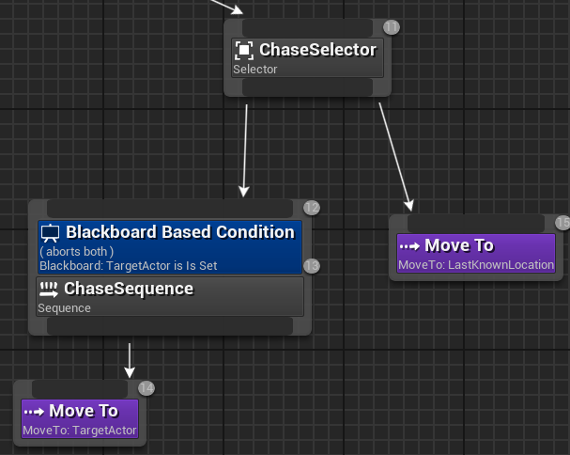
  1. Now to actually use these new nodes on the tree we will add an event from the perception component named “OnTargetPerceptionUpdated”, first we will call the “HandleSightSense” and plug in our actor and stimulus pins into the appropriate spots on our function, then we will call “HandleSoundSense”
  2. We now need to handle the sound portion for the player, because if the player doesn’t make any noise for the AI then that sense will be useless.
     1. First add a “PawnNoiseEmitter” component to the player.
     2. The first way we will handle this is by implementing the “OnLanded” event and from there we will call ”MakeNoise” from the noise emitter, the noise maker is the player so give it a reference to self, and the location will be the players current location.
* 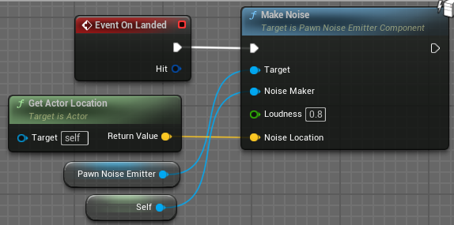
  + 1. We will create a new custom event named “OnStep” and first we will check if the player is NOT crouched, if this is true we will report a noise event, give the actor location, we will set the loudness determined by if the player is sprinting or not, and by this we will check the movement speed. We will see if the characters max walk speed is equal to the sprint speed, we will use a select float node, if the player is sprinting we will use the loudness to 0.6 and if the player is walking we will use the loudness of 0.3.
* 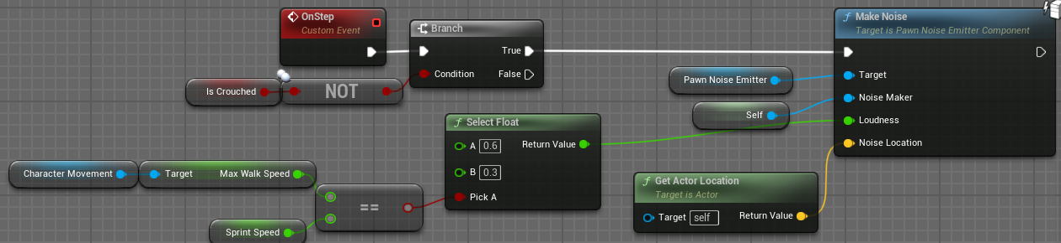
  + 1. Now we will use this OnStep within our animations. Find and open “FP_Run_Fwd” right-click on the graph and every 10 frames on channel 1 add a new anim notify named “Step”.
* 
  + 1. Now in the animation blueprint we will implement our AnimNotify_Step event. First we will branch and check if the owning actor is equal to the player, if it is then we will cast to our player blueprint and then call our OnStep event.
* 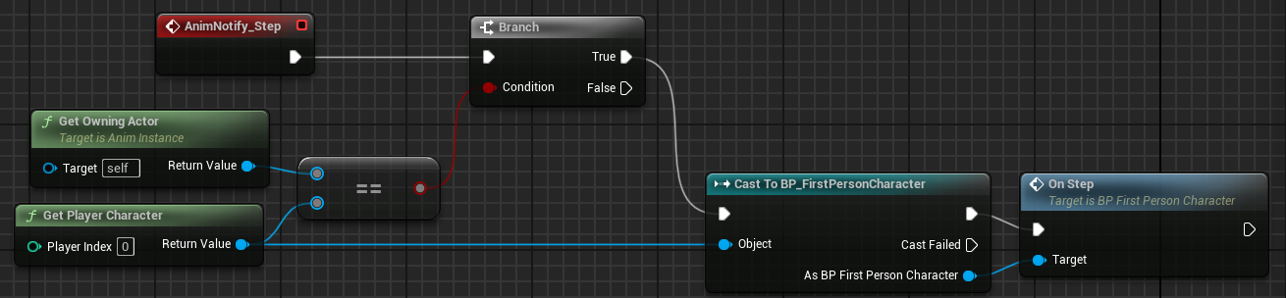

1. Now we will create the blueprint for the patrol enemy character. Create a new blueprint with the character class as the parent, name this “BP_PatrolEnemy”.
   1. Add our created “BP_AIBehavior” component to this blueprint.
   2. Add 3 float variables to the AI character, One will be named “SightAngle” set the default value to 45. The next one will be named “SightRadius” set the default value to 1000. The last one will be named “HearingRadius” set the default value to 1000.
   3. Now that we have these values we can set our perception values. In the patrol enemy controller on begin play we will set these values for the pawn sensing component. Call “SetPeripheralVisionAngle” on the sensing component and pass in the sight angle for that. Then set the sight radius to the sight range. Now set the hearing threshold to the hearing range and set the LOSHearing threshold to the hearing range doubled.

* 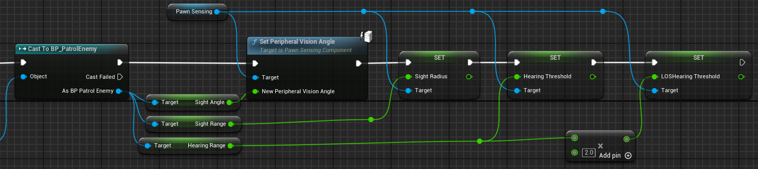

1. We will use a very basic mesh for our enemy, we will use the SK_Manny asset from unreal, and we will use a simple red material on the chest to indicate that it is a patrol enemy.
   1. Set the collision profile to ragdoll, this will be useful for us later when we perform a takedown the enemy will ragdoll onto the ground then will be destroyed after some time.
   2. Also at this time to make sure the animation blueprint works with the AI in the movement component set “UseAccelerationForPaths” to true.

Part 3: Slow Detection

1. The enemy can already sense the player now, however it is far too fast to be fair in the real application and there is no indication of whether or not the player has been sensed or is being sensed so we are now going to fix that.
   1. First step to fix this will be to add an UI widget to indicate to the player that we are being sensed. Create a new user widget and name it “WBP_DetectionMeter”.
   2. In the designer tab add a canvas panel, then add a progress bar and rename it to “DetectionMeter”. Using the provided textures set the background image to the empty version, and the fill texture to the filled version, make sure both of these have the draw as setting set to “Image”. Now set the fill type to “Fill from Center Horizontal”. Set the size of the slider to X: 150 and Y: 40, set the anchor to the middle of the screen, set the alignment to 0.5 on X and Y, and set the Y position to -175. By default make sure the default visibility is set to “Hidden”. Now in the transform section set the pivot to X: 0.5 and Y: 5.
   3. In the event graph section of this blueprint we will add a custom event named “UpdateAngle” with a float input. Get our progress bar and call “Set Render Transform Angle” and set the angle to the incoming float value.

* 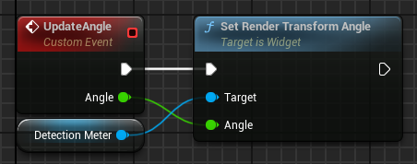
  1. Now we will add a reference to this blueprint on the patrol controller blueprint, and create a widget on begin play as we did for the player HUD and save the reference for later.

1. Next we will create a blueprint interface, you can find this by right-clicking in the content browser and under “Blueprint” you can find the interfaces. Name this “BPI_Detection”.
   1. Here we will add 4 functions.
      1. “StartDetection” with a character input and a progress bar passed in by reference.
      2. “StopDetection”
      3. “StartChase”
      4. “StopChase”
   2. We will then add this interface to 2 of our blueprints. First one being our “AIC_PatrolEnemyController”, we can do this under the “Class settings” menu and in the details panel find “Interfaces” and under the implemented interfaces add our newly created interface. Also add this to the player character using the same method that we used for the controller.
2. On the player we will implement the start and stop detection events from the interface. We will begin with the start detection event. First we will get the detection meter reference from the event and get the visibility, check this on a branch, if it is not visible we will set the visibility to true, and both exec branches will go into a new timeline.
   1. Name this new timeline to “FillDetectionMeter”, add a new track named “DetectionFillTrack” set the length to 3, add 2 keyframes, first one at time of 0 with a value of 0, second one at time of 3 and value of 1.

* 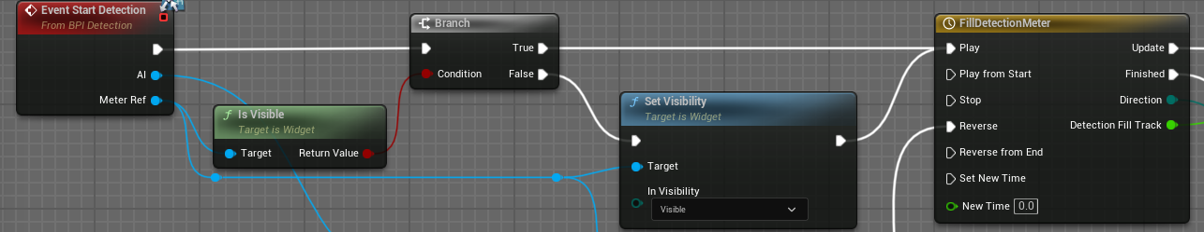
  1. Off of the Update exec pin we will get the progress bar and update the percent value to the output of the timeline node. On the finished exec pin we will switch on the direction enum, if it is forward we will set the progress bar color to red and then call start chase on the AI controller. On backward we will call a retriggerable delay of 0.5 seconds, then set the visibility of the widget to hidden, call stop chase on the AI controller then set the fill color of the progress bar to white.
* 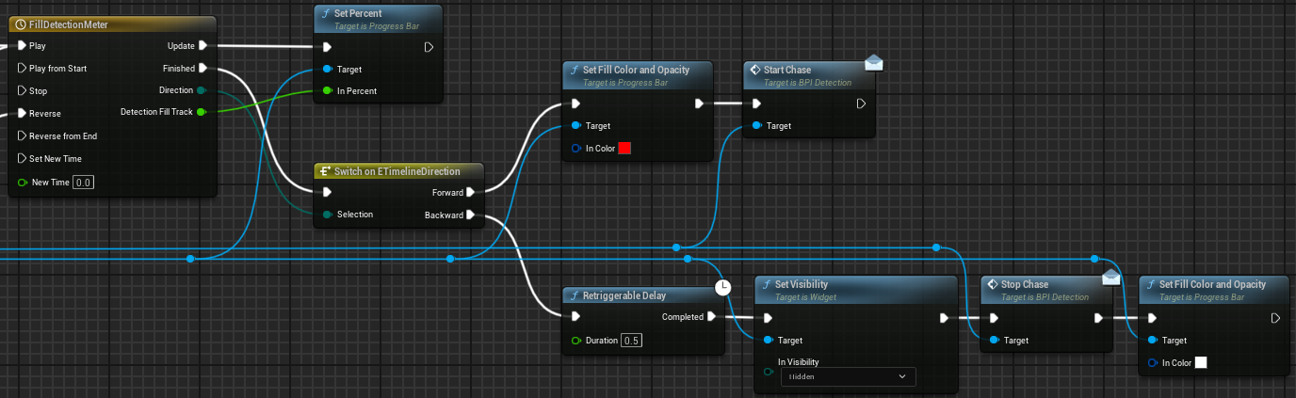
  1. Then for our stop detection implementation call stop on our timeline then reverse the timeline.
* 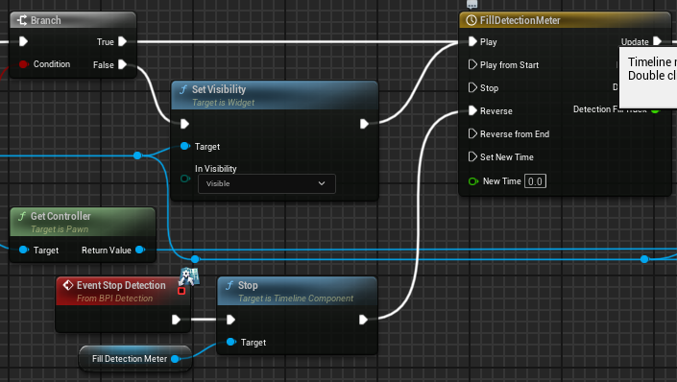

1. Next we will implement the start and stop chase functions on the AI controller.
   1. We will create a new vector variable to store the player's last seen location, and also add a boolean variable to determine whether or not we should update the rotation of the detection meter.
   2. In the “OnSeePawn” event we will be altering the code that we have, we will be changing everything after the branch node. First set the value of “bShouldRotateMeter” to true and set the last seen location equal to the player’s current location. Then we will use a sequence node, the “Then 0” exec pin will go into a do once node which will then call start detection on the player character. Off of the “Then 1” sequence will go into a branch node, put the event bool input into this branch, off of the false exec we will call stop detection on the player character. Which will then go into the reset pin on the do once node.

* 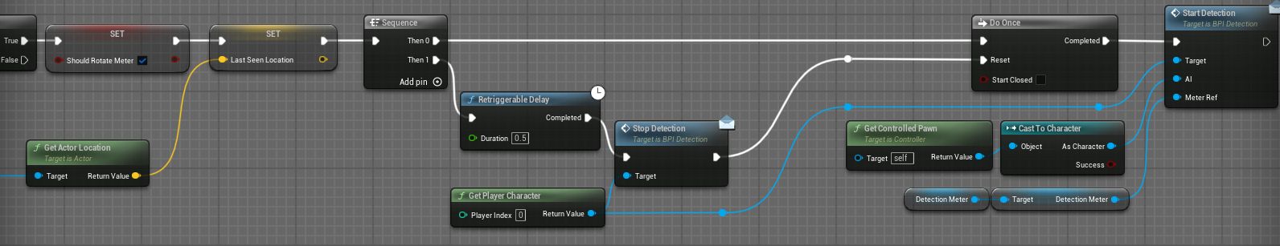
  1. Now to implement the start and stop chase events, on start we will set value as object on our blackboard and the name to be passed in will be “TargetActor”.
* 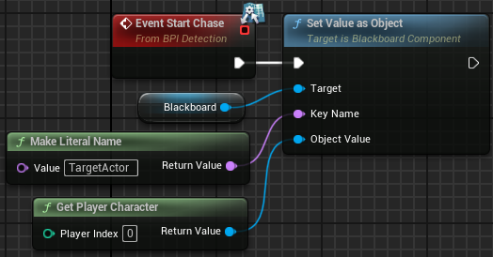
  1. Now on stop chase we can call clear value on the blackboard looking for the key named “TargetActor”. Then we will set value as vector, the name to be passed in will be “LastKnownLocation” and pass in our last seen location vector.
* 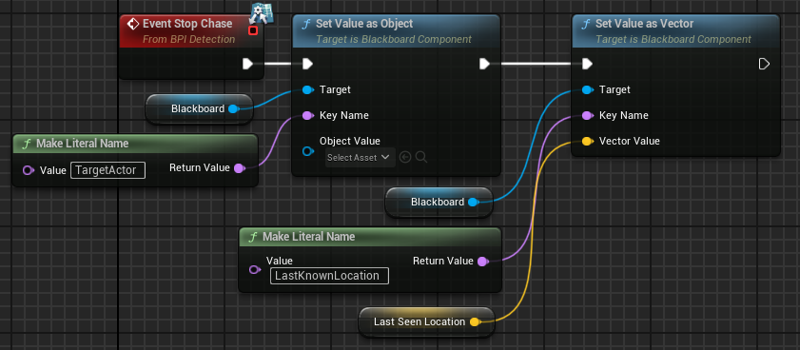
  1. Create a new custom event in the controller named “UpdateDetectionMeterRotation”. We will get the player pawn and controlled pawn and get the location of both actors. Using a “Find Look at Rotation” node plug in the player’s location to the start pin and the AI to the target location. Break the given rotator and take the Z component and subtract the players control rotation Z component from it. Then the difference of these 2 values will be sent into our “UpdateAngle” event.
* 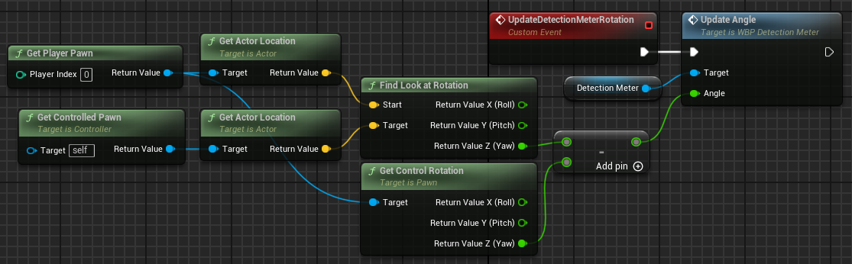
  1. On the tick event, using a branch node check if the rotation of the detection meter should be updated or not, if it should call the update function.
  2. In the player blueprint at the end of the backward exec line in “StartDetection” add a cast to the patrol controller and set the rotate meter value to false.
* 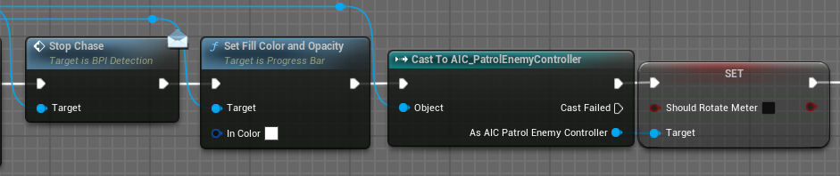

Step 4: Alert AI

1. Now we will work on the second type of AI which will immediately see the player, begin attacking then alert all the patrol AIs within a modifiable range.
   1. We will start this off by adding a couple events to our patrol enemy controller. We have “OnStartAlert” with a vector input as the player’s last location. The other custom event will be “OnStopAlert” with no inputs. When the AI enters the alerted state it will have heightened senses, so we will take the values from the AI character and multiply them by 1.5, however we will keep the vision cone the same angle. We will also set the “LastKnownLocation” key to the vector that is passed in by the event.

* 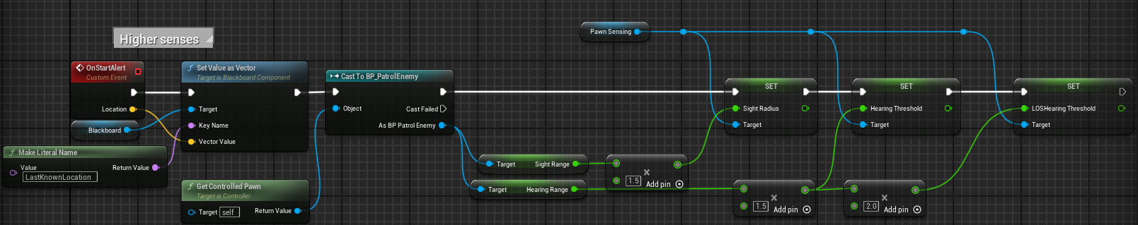
  1. The OnStopAlert event will be very similar so we can copy and paste what we have above and alter a few things. First thing is we are going to call clear value instead of set value. Then for all of the values we set just remove the portions where we multiply the values by 1.5.
* 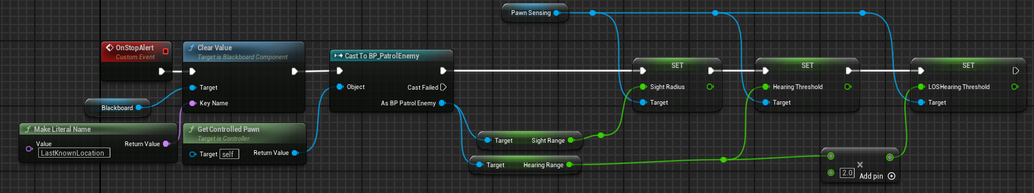

1. Now we will set up the behavior tree and blackboard for this enemy type. We will name these “BT_AlertEnemy” and “BB_AlertEnemy” respectively.
   1. We will be adding 2 keys to the blackboard, one of type vector named “InvestigationLocation” and the other of type object with a base class of “Actor” and this will be named “TargetActor”.
   2. The behavior tree will be very easy to set up, the entire left side will be copy and pasted from our patroller behavior, using this we can use the patrol nodes to set up where the alert enemy should look and very subtle movements. The decorators will be the same as well, one is named “InvestigationLocation” instead of “TargetLocation”.
2. We are going to create a new actor blueprint that will be the projectile launched towards the player, name this “BP_ProjectileActor.
   1. We will add a sphere mesh component to this actor and give it the solid blue material.
   2. In the details panel of the sphere component, turn “SimulatePhysics” to true, and set the mass to 0.001. Under the collision section change it to custom and set it to overlap on type “Pawn”.
   3. This will be a very simple event graph, off of begin play we will have a delay node which will act as the projectile lifetime, then once the delay is completed we will destroy the actor.

* 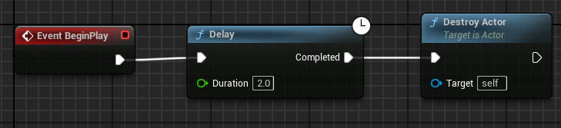

1. We will create a new BTTask for attacking the player, name this “BTTask_AttackPlayer”.
   1. Start this off as any other BTTask, override the receive execute AI event. First we will set the rotation of the controlled pawn to look at the player’s location. We will also add an instance editable float named “ShootCooldown” with a default value of 2 and another one named “ShotPower” with a default value of 500.

* 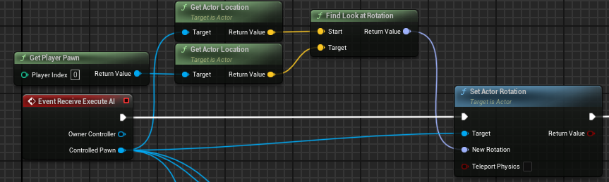
  1. Now we will spawn an actor by class and provide the projectile actor we just created. For the spawn location we will get the actor forward vector, multiply it by 30 and add it to the actors location to spawn the projectile slightly in front of the actor. Then set the rotation of the spawned actor equal to the rotation of the actor.
* 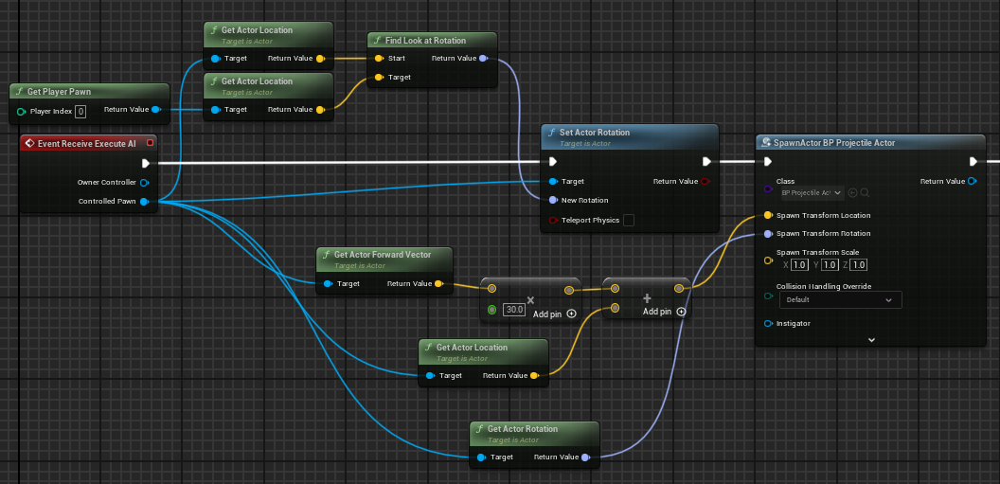
  1. We will get the sphere component and call “AddForce” and for the force vector get the forward vector of the actor and multiply it by our shot power. Then using a delay node we will put our shot cooldown in the duration pin and finally call finish execute with success set to true.
* 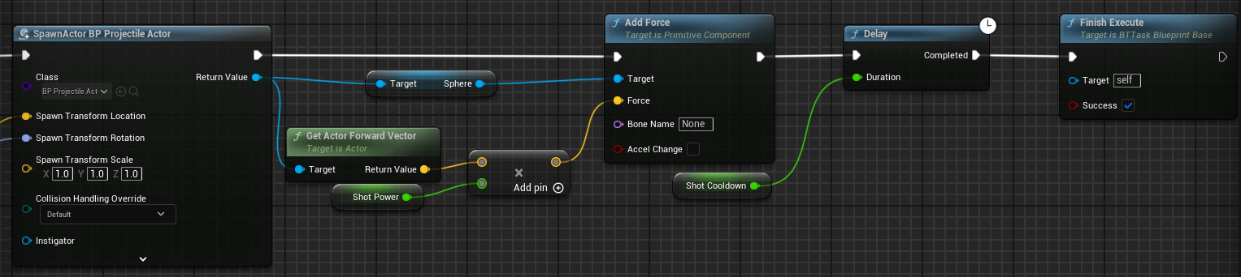

1. Now we can add this task to our behavior tree and have it set on a sequence where it will only go down that path if the target actor is set and valid and we do not want the tree to abort anything if it is set.

* 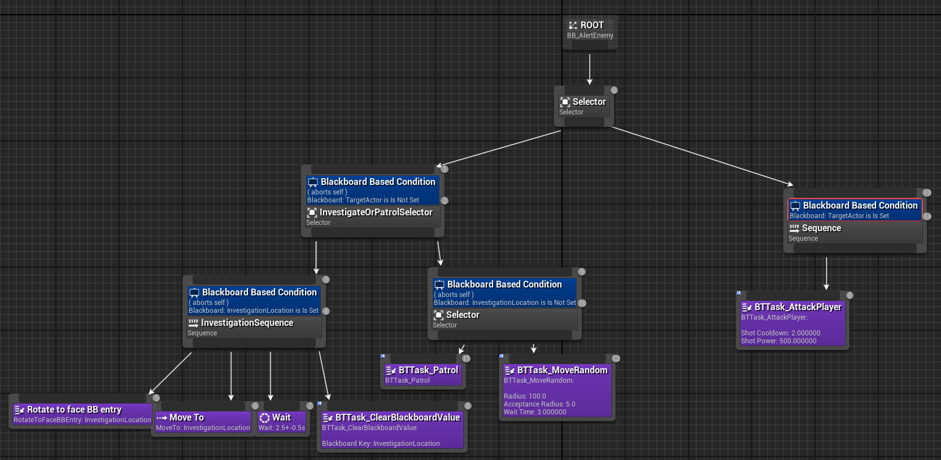

1. Now we will take a look at the controller for the alert enemy. First create a new AIController blueprint and name it “AIC_AlertEnemyController”.
   1. Add the pawn sensing component to the blueprint. On begin play, call run behavior tree and the asset will be “BT_AlertEnemy”. We will set the values for the pawn sensing component the same way we did for the patrol enemy.

* 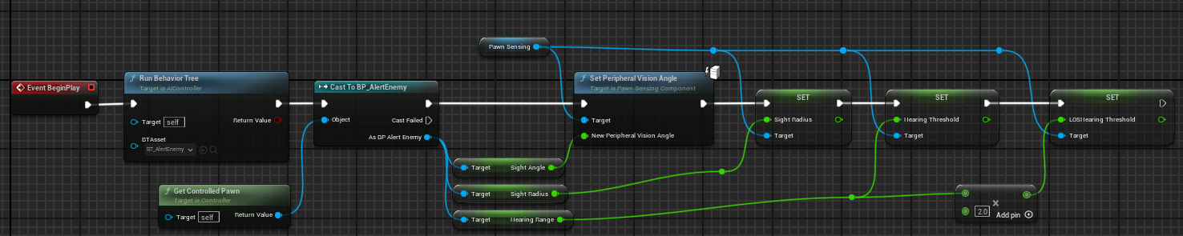
  1. Now we will implement the “OnSeePawn” event. Start by getting the player character and seeing if it is equal to pawn incoming from the event casted to a character. If they are not equal we will do nothing. If they are equal we will go into a sequence node, the “Then 0” exec pin will go into a “Do once” node. We will start by filling out the “Then 1” exec pin. We will start with a retriggerable delay, off of the delay we will clear the “TargetActor” value. Then we will get all actors of the class “BP_PatrolEnemy”, we will then use a foreach loop on the output array and on each array element we will get the controller and cast it to our patroller controller and call “OnStopAlert”, off of the completed exec pin we will go into the reset pin on the do once node.
* 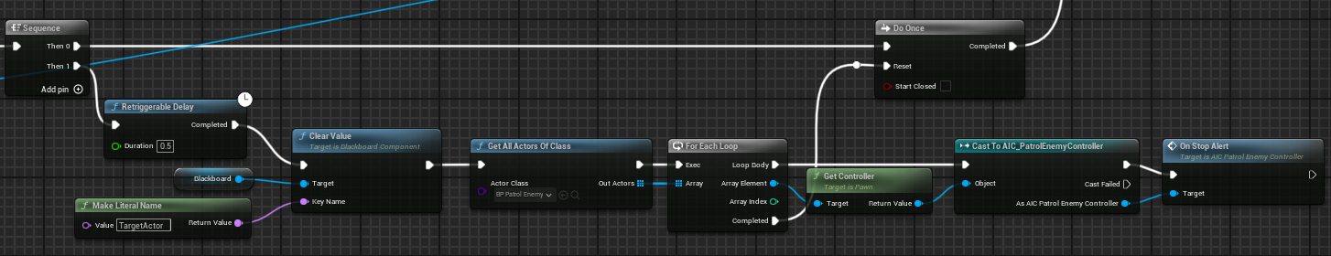
  1. Now we will focus on the completed pin of the do once node. We will first set our “TargetActor” blackboard value to our player. Next we will do a “MultiSphereTraceForObjects”, the start and end location will be the location of the controlled pawn. Cast the controlled pawn to our alert enemy class and get the “AlertRadius” variable and use it in the radius pin. We will make an array and only look for overlaps of type “Pawn” and for the actors to ignore we will ignore “self” and the player character.
* 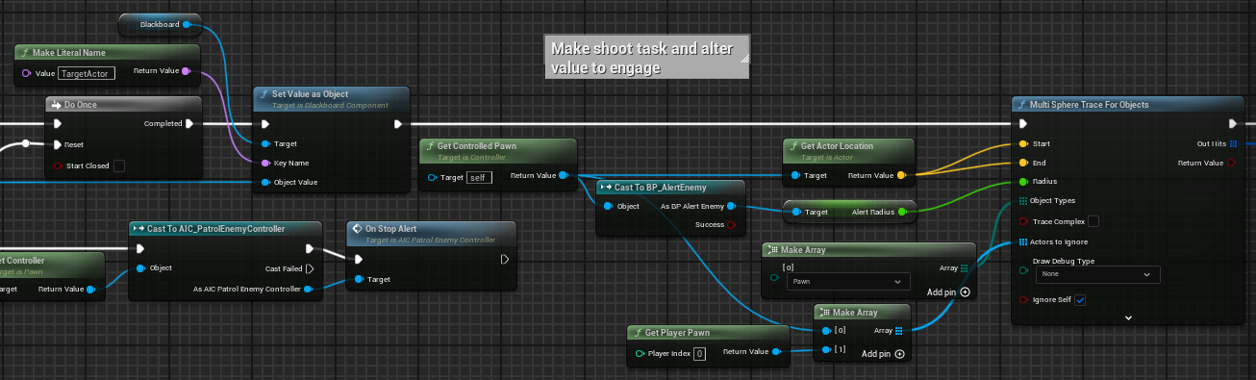
  1. Now we will get an array of hit structs, perform a foreach loop on this array, break the hit result and cast the hit actor to our patrol enemy class. If it is successful, get the controller of the class and cast it to our patrol controller class and call “OnStartAlert” and use the player's location.
* 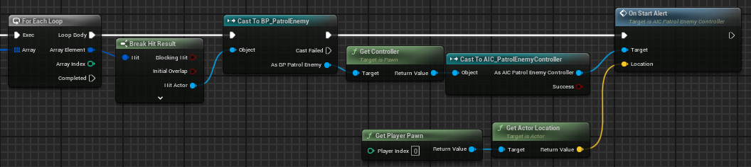
  1. Now we will implement the On Hear Noise event for the alert enemy. First check to see if the instigator is equal to the player character. If they are equal then set our “InvestigationLocation” on our blackboard to the location from the event.
* 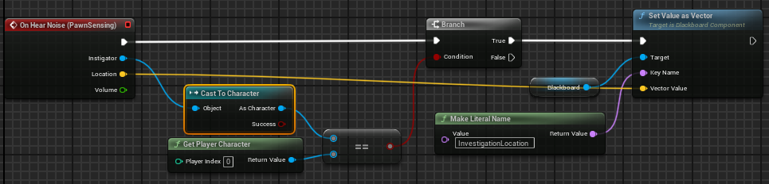

1. We will use a very basic mesh for our enemy, we will use the SK_Manny asset from unreal, and we will use a simple red material on the chest to indicate that it is a patrol enemy.
   1. Set the collision profile to ragdoll, this will be useful for us later when we perform a takedown the enemy will ragdoll onto the ground then will be destroyed after some time.
   2. Also at this time to make sure the animation blueprint works with the AI in the movement component set “UseAccelerationForPaths” to true.

Step 5: Takedown system

1. First step in the takedown system we will add a new interface. Name this “BPI_Combat”. This will have 2 functions.
   1. First one will be “OnHit” with a float input to represent damage.
   2. Another one named “OnTakedown”.
2. We will add this interface to both AI character types and the player.
   1. On both AI types we will add a custom event named “DeathRagdoll”
      1. This is a very simple event, all we will do is call “SetAllBodiesSimulatePhysics” on the mesh component and set it to true.

* 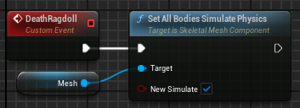
  1. On the Alert enemy we will implement the “OnTakedown” event. First we will turn off collision on the capsule component. Have a half second delay then destroy the actor.
  2. The patrol character will be a bit more complicated since there’s more things we need to disable before destroying the actor.
     1. First we will get the controller of the pawn, call “StopChase”, set the capsule collision to disabled. From the controller, cast it to our patrol controller, get the detection meter and remove it from the parent, then set “bShouldRotateMeter” to false, call “DeathRagdoll”, add a 2 second delay then destroy the actor.
* 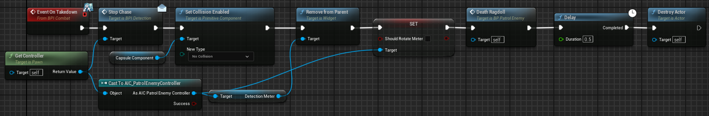
  + 1. In our projectile actor implement the “OnComponentBeginOverlap” event from the sphere component. Cast the “HitActor” to the player class and call our OnHit message interface and send in a value of 1 for damage.
* 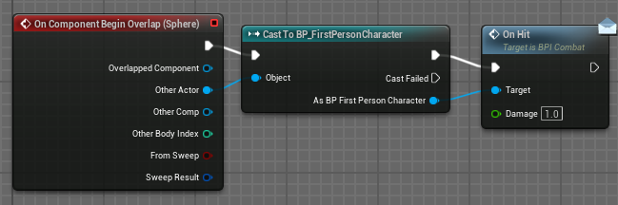

1. Now we will work on the player side of the takedown system.
   1. Add a boolean to the character and name it “bDetected”.
   2. Add the IA_Takedown event, off of the started pin go into a branch node and check if NOT detected, off the true branch we will do a “SphereTraceForObjects” node.
      1. The start value will be the actors location.
      2. The end value will be the actor forward vector multiplied by 100 then added to the location.
      3. Set the radius to 100.
      4. Drag off of object types and use “MakeArray” and we will look for type Pawn.
      5. Then the only actor we will ignore is “self”.

* 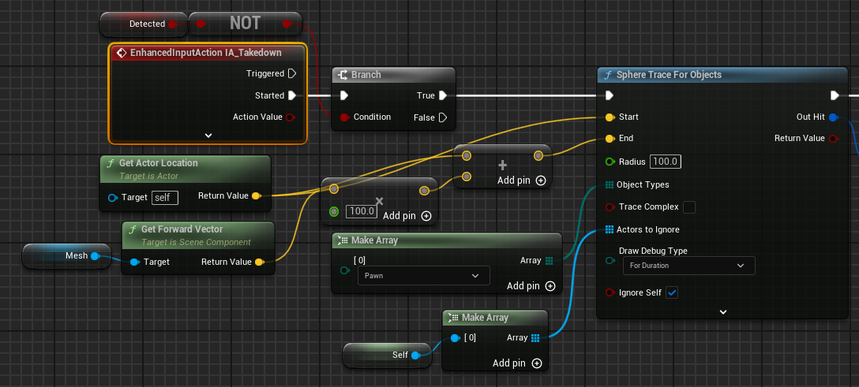
  1. Break the “out hit” struct and check if the hit actor is valid, if it is valid we will then check if the player is behind the pawn.
     1. To do this first we will subtract the player’s location from the hit actors location, then normalize the resulting vector.
     2. Then get the forward vector of the hit actor and perform a dot product on the forward vector and our normalized vector.
     3. If the result is greater than or equal to 0 that means we are behind the AI.
  2. If the previous result is true then we will call the interface method “OnTakedown” on the hit actor.
* 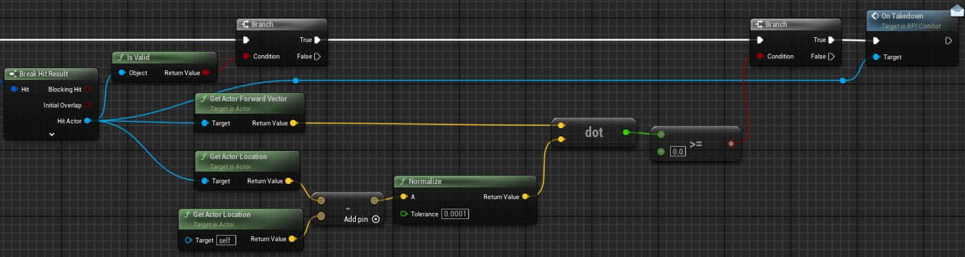

Step 6: Win/Loss conditions

1. For our loss condition we aren’t going to do a traditional health system, but more of a system where the player can only take so many hits.
2. First thing we will setup is the win/loss screen, both will have basic text and 2 buttons that do the same thing, so we will make the logic a little bit smarter and keep it all in 1 blueprint.
   1. Create a new widget blueprint named “WBP_WinLoseScreen”. First add a canvas panel to the widget. Add a text element named “WinLoseText” and make sure it is a variable, with the anchor set to the middle of the screen. Set the Y position to -320.
   2. Add a button name it “RetryButton” and give it a text child, set the anchor to the middle of the screen, and set the Y position to -120, set the size to X: 200 and Y: 50. Set the background color to 0.2 on the R, G, and B elements. Set the text in the button to “Restart”. Now duplicate this button, name it “QuitButton” and set the Y position to -30.

* 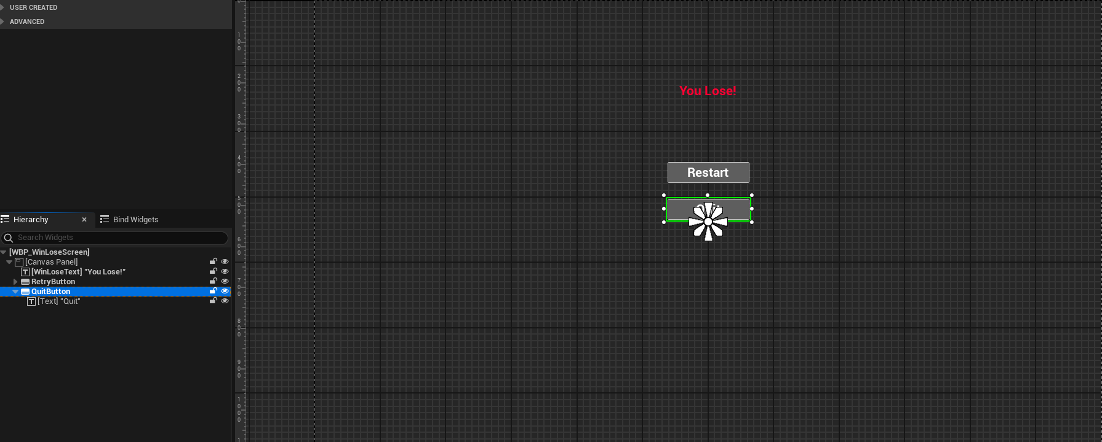
  1. Now in the event graph we will implement the “OnClicked” events for both buttons. On click for the retry button we will get the current level name, then open level by name, then we will get the owning player and call “SetInputModeGameOnly”.
* 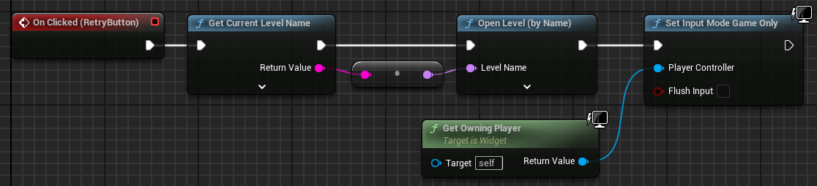
  1. Next we will implement the click event for the quit button.We will get the owning player and call “QuitGame”.
* 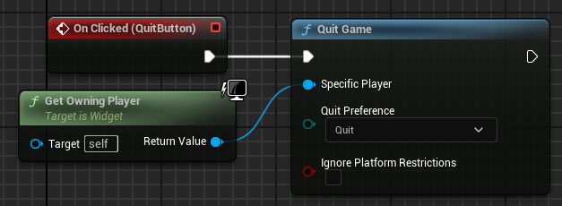
  1. Now we will create a custom event named “SetTextAndColor” this will handle what text we will display when this screen is shown to the player. Add a bool input to this named “Win”. We will select text on bool the true text is “YOU WIN!” and the false text is “You lost!”, the return of this node will be sent into a “SetText(Text)” node on our win lose text element. We will select a “SlateColor” on bool and use the set color and opacity node with our text as the target. The color on true will be green and the color for false will be red.
* 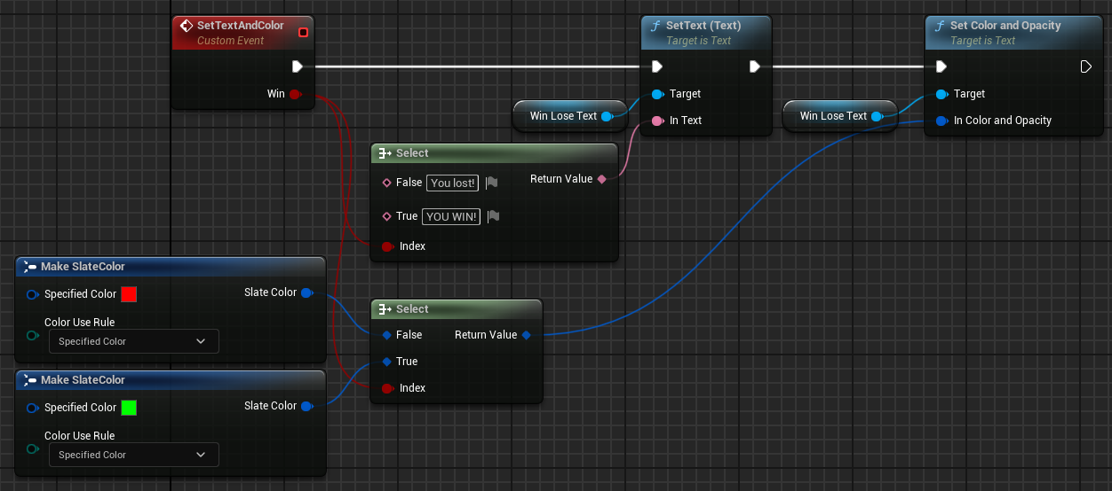

1. Open the HUD blueprint. Add an image element that spans over the entire screen. Name this “HealthVignette” this will be a visual indicator to the player how many times they’ve been hit, set the image value to the vignette texture. By default set the opacity to 0. Create a custom event named “UpdateHealth” with a float input that will represent a ratio, then call “SetOpacity” on the health vignette.

* 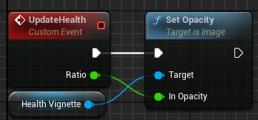
  1. Now on the player blueprint we will add a reference to our win lose screen and we will add 2 int variables one named “HitsAllowed” which will determine how many times the player can be hit before losing and the other will be named “HitsLeft”. At the end of begin play we will set hits left to the value of hits allowed, we will also create our widget and store a reference to it.
  2. We are going to make a new custom event that will handle showing our end game screen. Name it “ShowEndScreen” with a bool input, the first thing we will do is pause the game so nothing happens in the background. We will then use our set text and color event on our widget, then add it to the viewport. We will then get the player controller and set the input mode to UI only and tell unreal to show the player the mouse cursor.
* 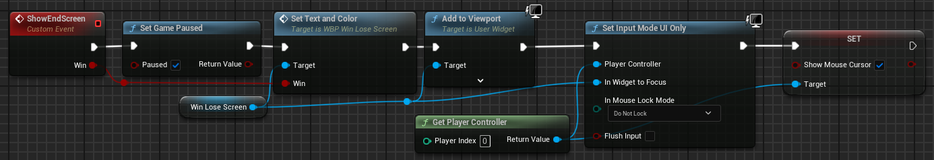
  1. We will now implement our OnHit event, first we will decrement our hits left value, then check if its equal to 0, if it is we will then call show end screen with the win box unchecked. If it is false then we will update the health. To do this the equation will be 1 - ((float)HitsLeft/(float)HitsAllowed), and send the result in as the ratio. We cast our integers into floats so that the decimal does not get truncated.
* 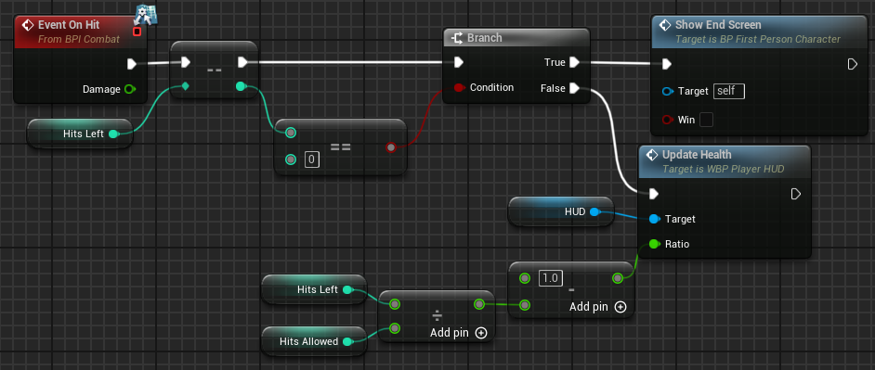

1. That is the lose condition handled, now we will add a win condition. First we will create a little collectable object that the player has to find. Create a blueprint actor and name it “BP_IntelCollection”.
   1. We will add 2 cube meshes with a scale of X: 0.3 Y: 0.3 Z: 0.01, make one a child of the other, set the location of the child cube to X: -1.18 Y: 0 Z: 470 and rotate it 18 degrees on the Y axis. Now add a sphere collider and set the scale to 1.5.
   2. Quickly on the player character we will create a new custom event named “PickupIntel” and add an int variable named “IntelCollected”. For now all this event will do is increment the intel collected variable.
   3. Implement the “OnComponentBeginOverlap” event for the collider. We will check if the other actor is our player character, we will then call “PickupIntel” and then destroy the actor.

* 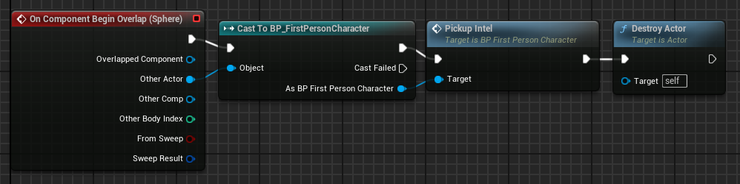

1. Next we will create a new blueprint actor named “BP_WinZone” which will be the zone we want the player to reach once they have collected all of the intel.
   1. Add a box collider component. We won’t worry about the size of this currently since we can change that when we place an instance of the blueprint.
   2. On begin play we will call “GetAllActorsOfClass” and the class we will look for is our intel collection class, get the length and promote that to a variable named “IntelCountGoal”.

* 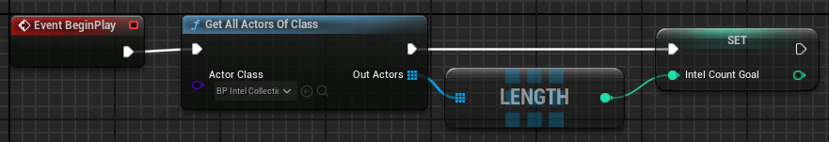
  1. Implement the component begin overlap event, we will cast the other actor to the player and get our intel count and see if it’s greater than or equal to our intel count goal, if it is we will call our show end screen event with the win box checked.
* 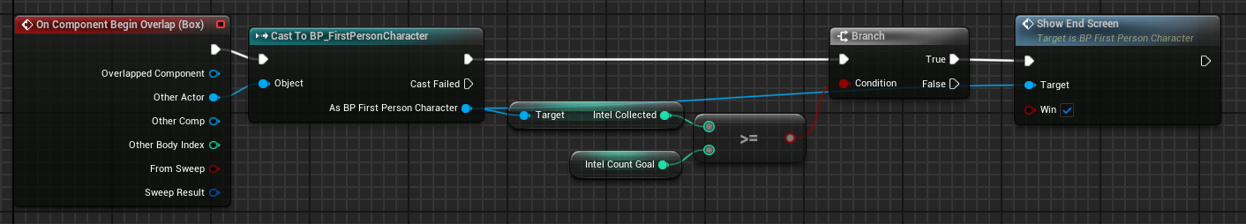

1. Now we will add some extra elements to the player HUD so they can know how many intel objects they need to pick up and how many they have.
   1. Add a text element, the displayed text in this will be static so we don’t need it to be a variable. Set the anchor to the middle right of the screen. Set the size to X: 150 Y: 40. Set the position to X: -48 and Y: -350. Set the text value to “Objective:”
   2. We will add another text element. This one we will be modifying the text content so make this a variable and name it “ObjectiveText”. Set the size to X: 250 and Y: 100, set the anchor the same as our other text element. Set the position to X: -48 and Y: -250 on this one make sure that “Auto Wrap Text” is set to true.
   3. Add a new integer variable, name it “IntelCount” this will be the amount of intel that needs to be collected. Now make a new custom event and name it “UpdateObjective” with an integer input to signify how many pieces of intel have been collected. On our objective text we will call “SetText(Text)” and we will check if the incoming count is equal to our intel count and select our text to populate accordingly. On true we will use “Return to the starting zone!” and on false we will use a format text node so we can send in our data easily. The formatted string looks like “Collect intel: {collected}/{needed}” and supply the corresponding variables

* 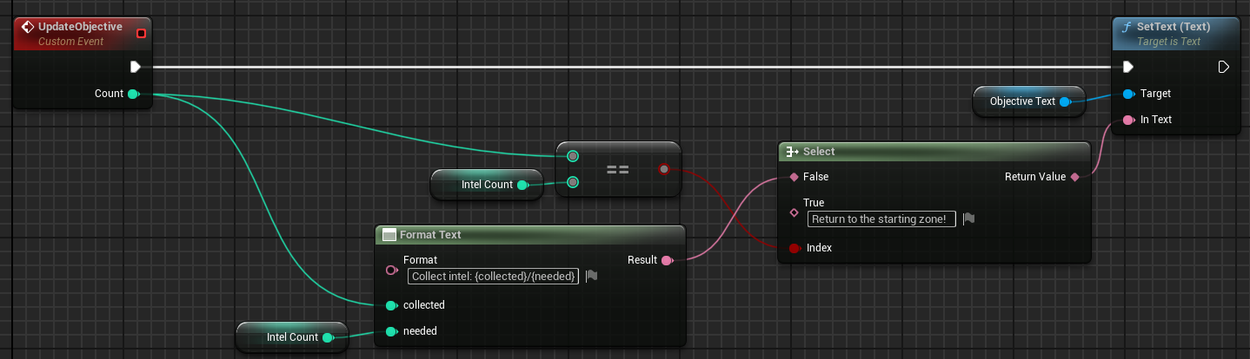
  1. We will implement the “OnInitialized” event. First call “GetAllActorsOfClass” and look for our intel collection class, get the length of the returned array, set our intel count equal to that then call our update objective event.
* 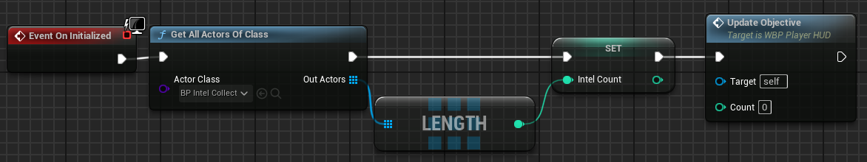
  1. Now in the player blueprint find our pickup intel node and at the end of it call update objective and send in the count that we have.
* 